# DAD Distinction Task – Template

Enter your Student ID: 103181157 Name: Nguyen Nam Tung

## **Part 1 ERDs and Schemas**

### Narrative 1 ERD

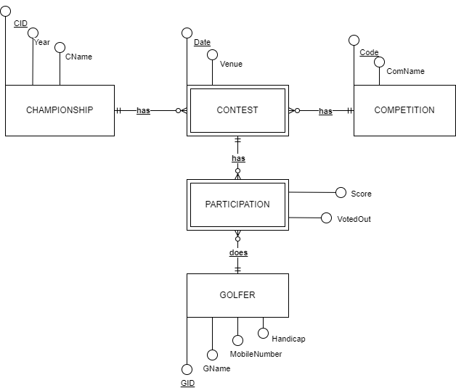

### Narrative 1 Schema

CHAMPIONSHIP (CID, Year, CName)

PK (CID)

COMPETITION (Code, ComName)

PK (Code)

GOLFER (GID, GName, MobileNumber, Handicap)

PK (GID)

CONTEST (CID, Code, Date, Venue)

PK (CID, Code, Date)

FK (CID) REFERENCES CHAMPIONSHIP

FK (Code) REFERENCES COMPETITION

PARTICIPATION (GID, CID, Code, Date, Score, VotedOut)

PK (GID, CID, Code, Date)

FK (CID, Code, Date) REFERENCES CONTEST

FK (GID) REFERENCES GOLFER

### Narrative 2 ERD

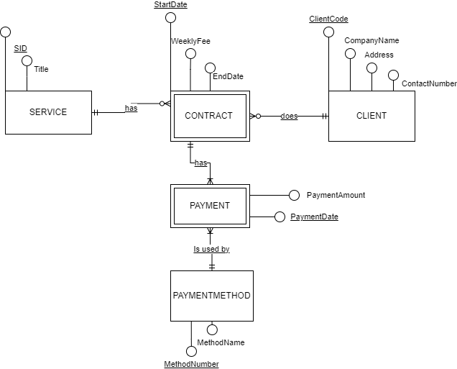

### Narrative 2 Schema

SERVICE (SID, Title)

PK (SID)

CLIENT (ClientCode, CompanyName, Address, ContactNumber)

PK (ClientCode)

PAYMENTMETHOD (MethodNumber, MethodName)

PK (MethodNumber)

CONTRACT (SID, ClientCode, StartDate, WeeklyFee, EndDate)

PK (SID, ClientCode, StartDate)

FK (SID) REFERENCES SERVICE

FK (ClientCode) REFERENCES CLIENT

PAYMENT (SID, ClientCode, StartDate, MethodNumber, PaymentAmount, PaymentDate)

PK (SID, ClientCode, StartDate, MethodNumber, PaymentDate)

FK (SID, ClientCode, StartDate) REFERENCES CONTRACT

FK (MethodNumber) REFERENCES PAYMENTMETHOD

## **Part 2 Building Database**

Design Views and Datasheet views of 3 Tables created here.

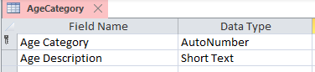

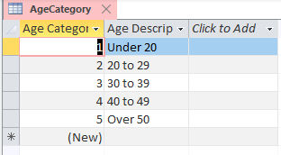

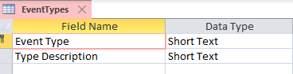

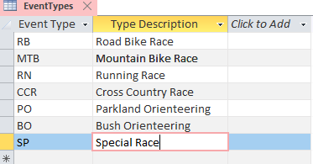

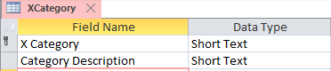

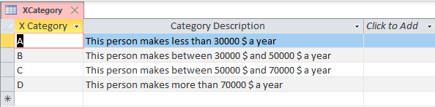

## **Part 3. Queries and Insert Data**

### Q1. People Query

### Design:

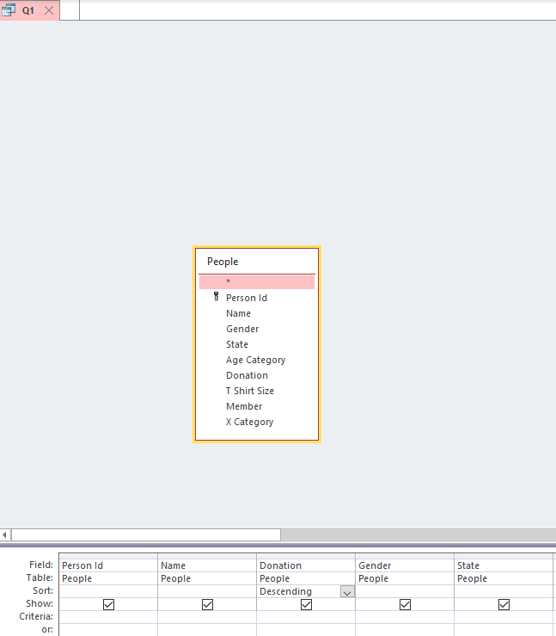

### Result Set:

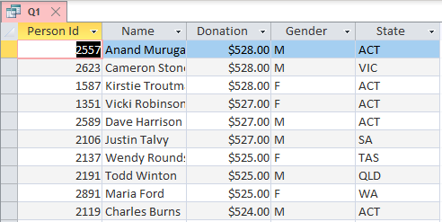

## Q2. Donation

### Design:

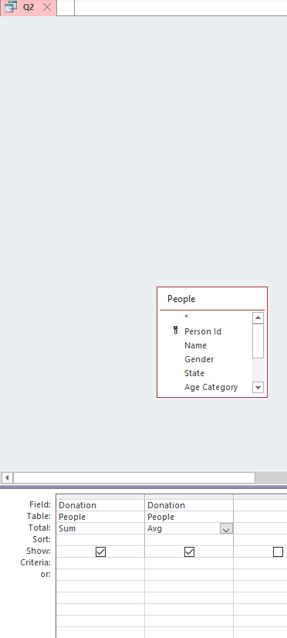

### Result Set:

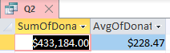

## Q3. Gender

### Design:

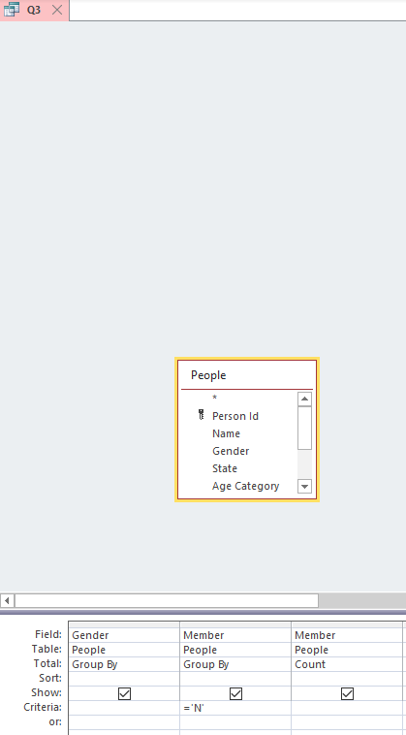

### Result Set:

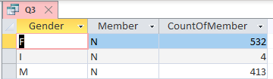

## Q4. Fastest

### Design:

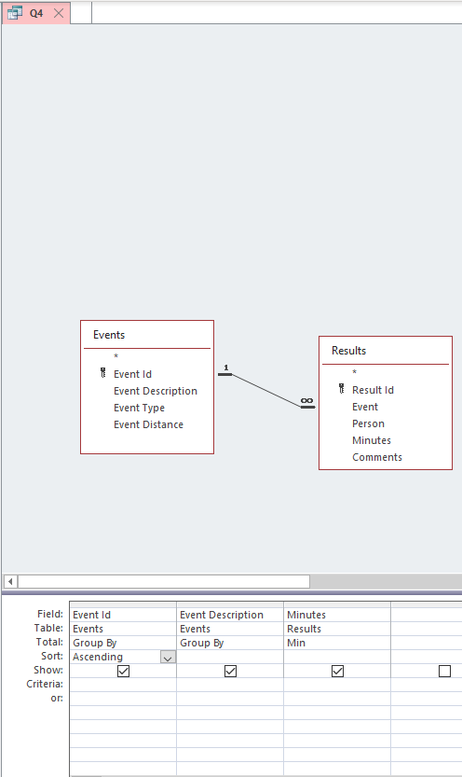

### Result Set:

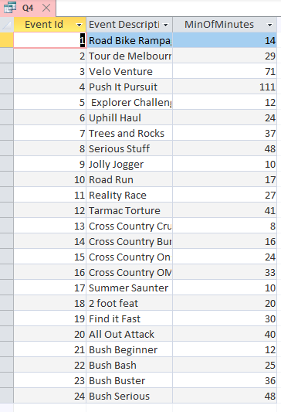

## Q5. Better than Average

### Design:

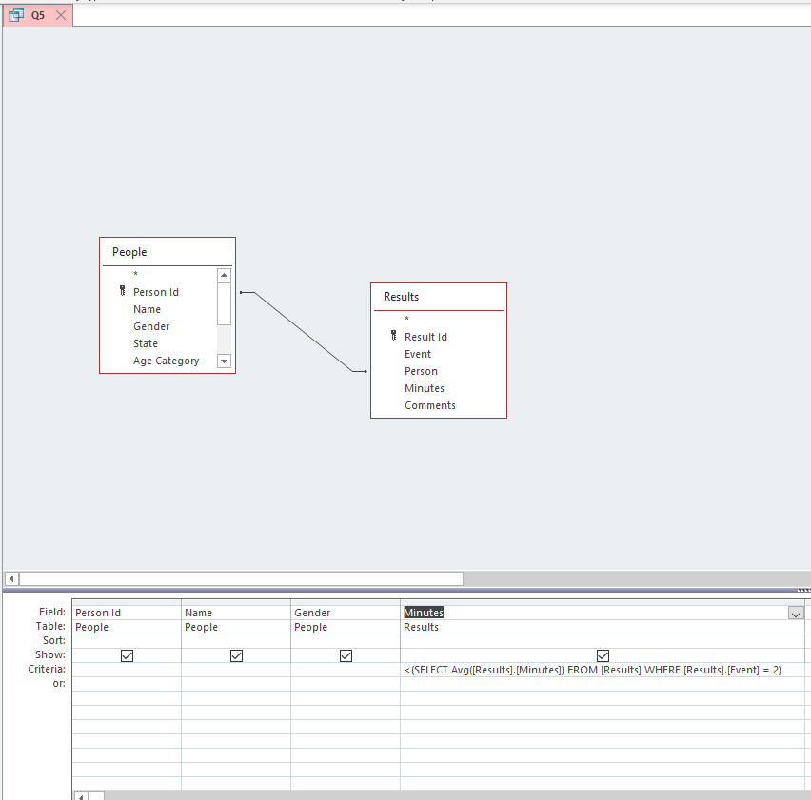

### Result Set:

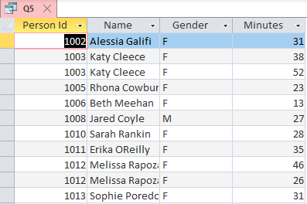

## Q6. Persons with No Results

### Design:

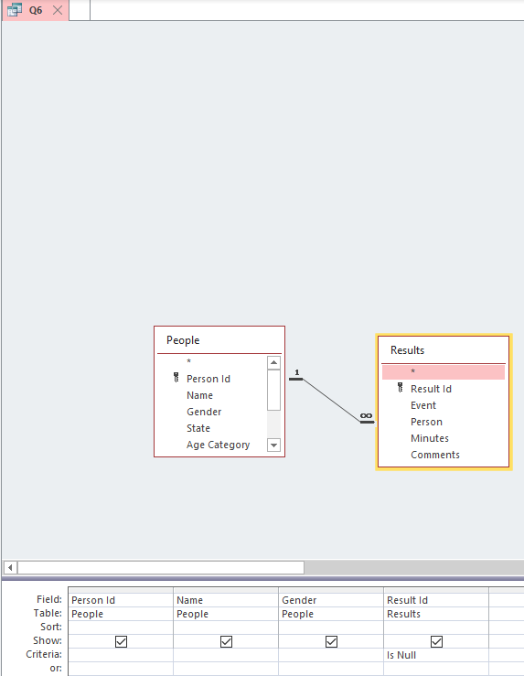

### Result Set:

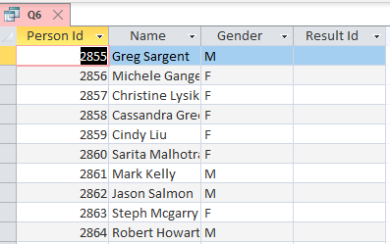

## Q7. XCategory

### Design:

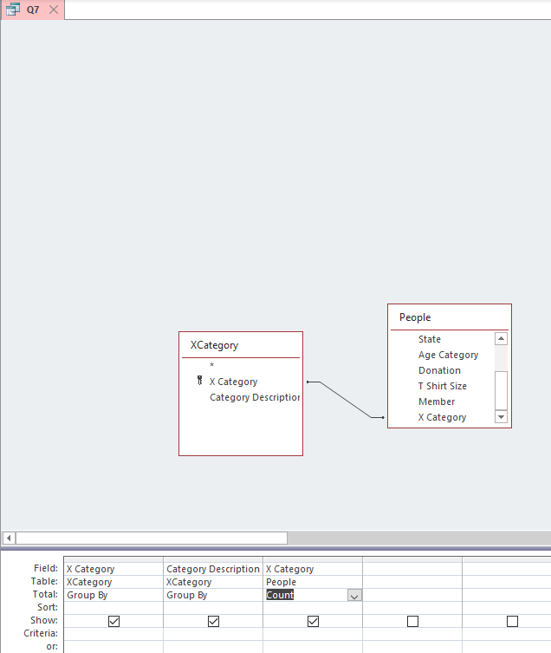

### Result Set:

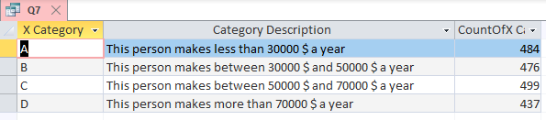

## Q7. Insert Your data and Event 25

### Result Set:

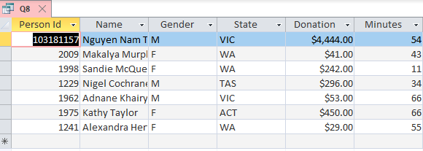

## **Part 4 Visualizations**

## Q1. Member Category Viz

### Settings:

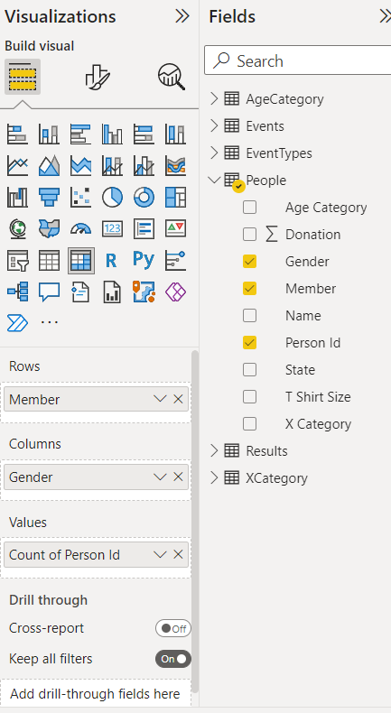

### Visualization:

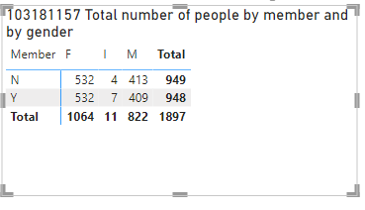

## Q2. Age Category Viz

### Settings:

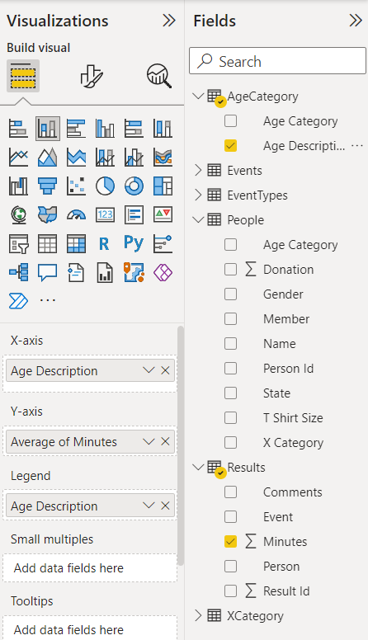

### Visualization:

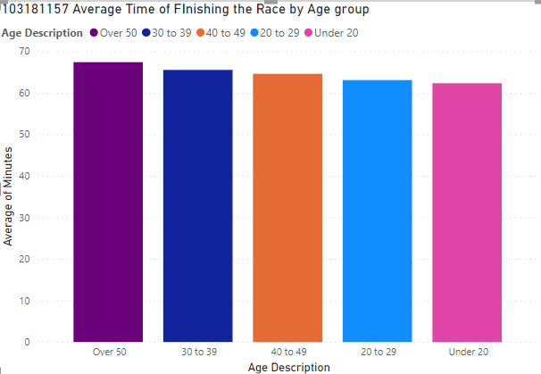

## Q3. X Category Viz

### Settings:

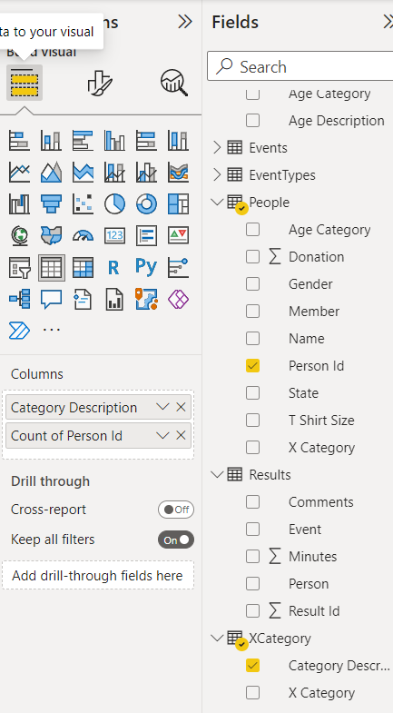

### Visualization:

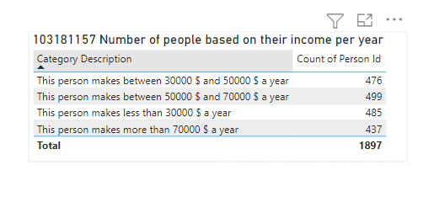

## Q4. Event Viz

### Settings:

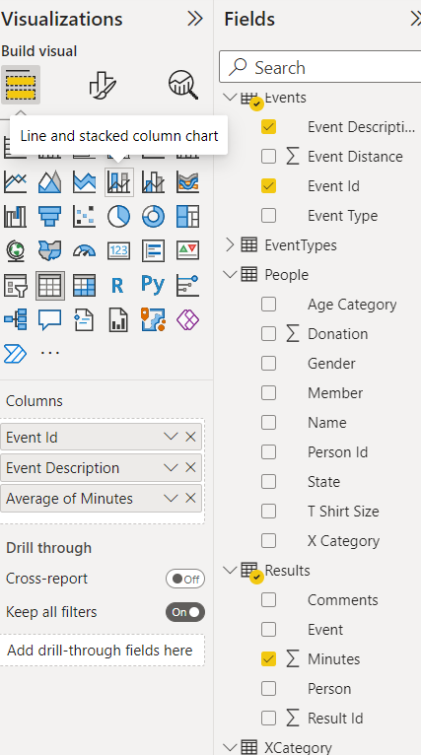

### Visualization:

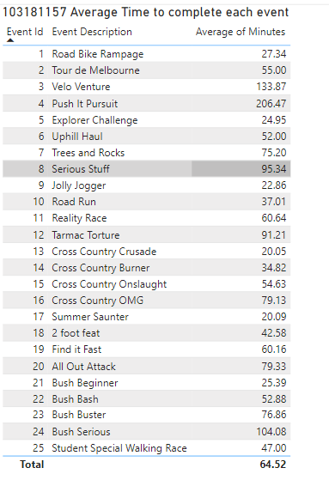

## Q5. Event 25 Viz

### Settings:

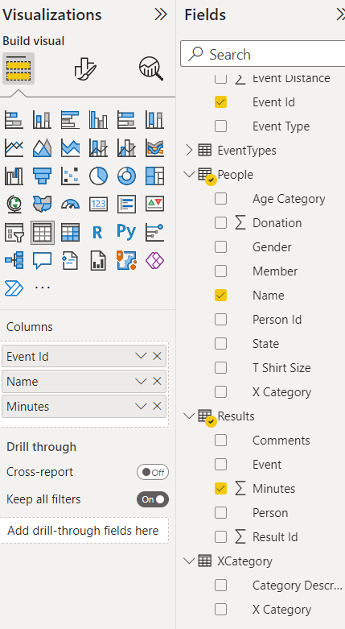

### Visualization:

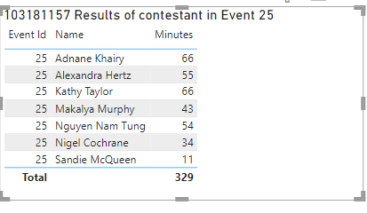

## Q6. Extra Viz 1

### Settings:

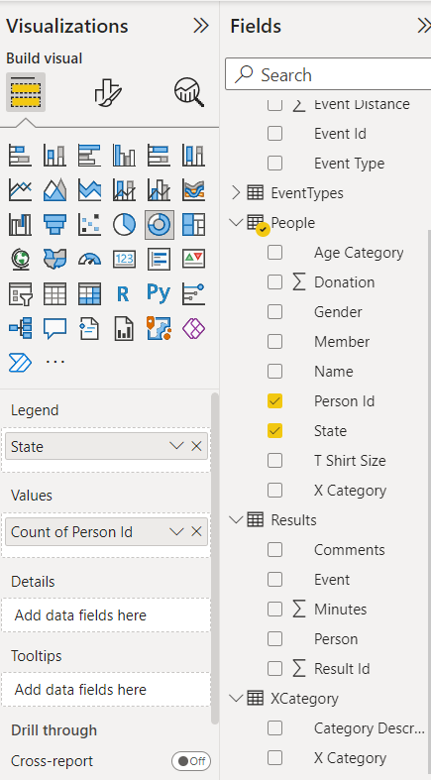

### Visualization:

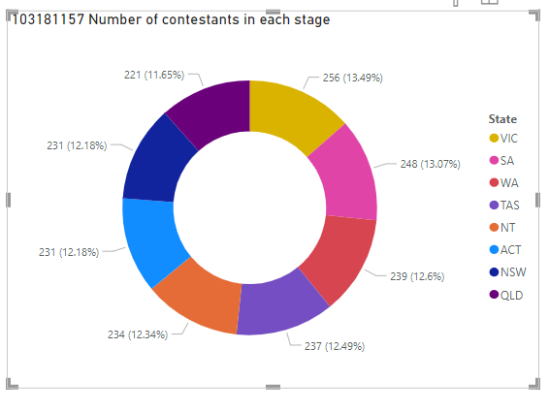

## Q7. Extra Viz 2

### Settings:

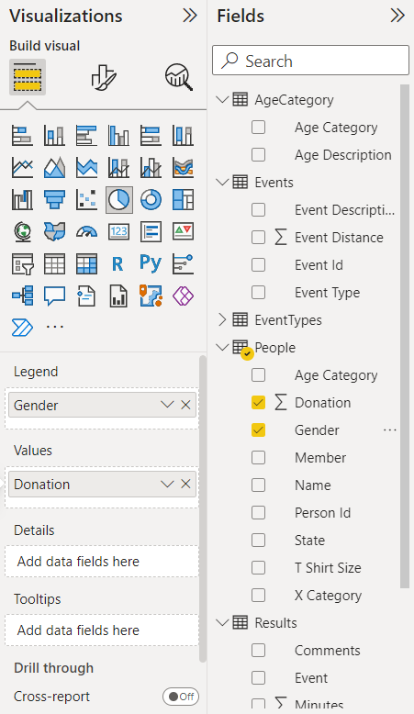

### Visualization:

